# Manipulating the Current Date and Time - Extended Exercise

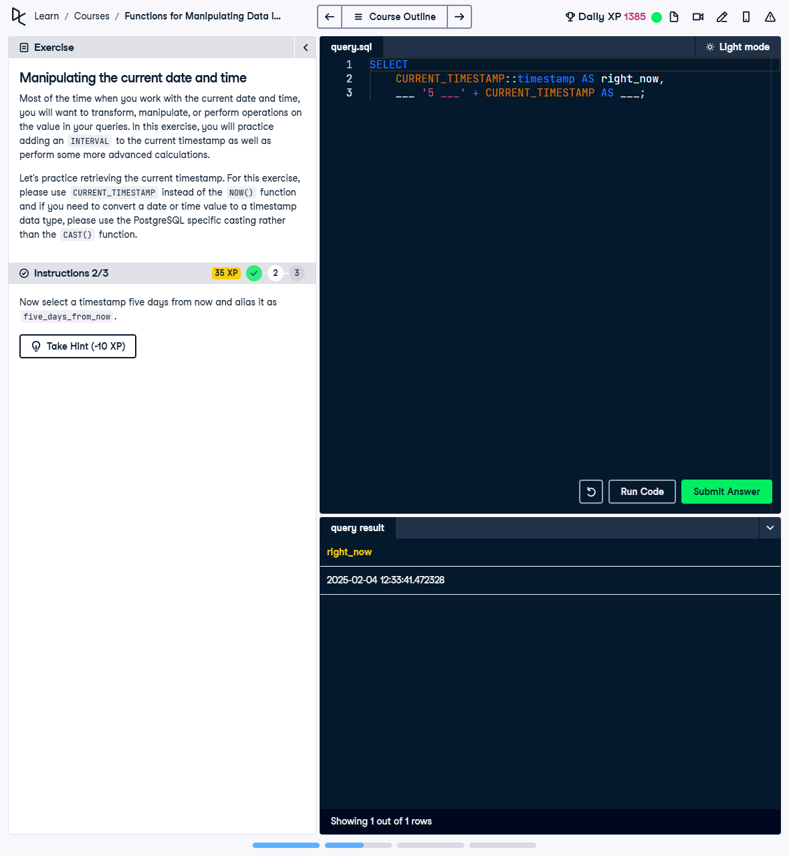

Question:

1. Select the current timestamp without timezone and alias it as 'right_now'.  
2. Select a timestamp five days from now and alias it as 'five_days_from_now'.

## Answer:

-- 1. Select the current timestamp without timezone and alias it as right_now  
SELECT CURRENT_TIMESTAMP::timestamp AS right_now;  
  
-- 2. Select a timestamp five days from now and alias it as five_days_from_now  
SELECT CURRENT_TIMESTAMP + INTERVAL '5 days' AS five_days_from_now;

## Explanation:

1. CURRENT_TIMESTAMP::timestamp: Retrieves the current timestamp and removes the timezone information by casting it to a type without timezone.  
2. CURRENT_TIMESTAMP + INTERVAL '5 days': Adds 5 days to the current timestamp using the INTERVAL function, providing a timestamp five days from the current moment.  
3. AS right_now / AS five_days_from_now: Assigns aliases to the results for better readability in the output.